**3**

**Vectors**

|  |
| --- |
| **CHAPTER OUTLINE** |

3.1 Coordinate Systems

3.2 Vector and Scalar Quantities

3.3 Basic Vector Arithmetic

3.4 Components of a Vector and Unit Vectors

* An asterisk indicates a question or problem new to this edition.

|  |
| --- |
| **SOLUTIONS TO THINK-PAIR-SHARE AND ACTIVITIES** |

**\*TP3.1 Conceptualize** Imagine your situation, staring at a radar screen with five ships indicated. You want to choose which ship to send, but how do you do it, especially when they all have different speeds? Should you simply send the ship that has the highest speed?

**Categorize** Based on the assumption in the problem statement, we can use the particle under constant velocity model for each ship.

**Analyze** First, find the *x* and *y* components of the four ships, as well as the sinking ship, using east as the +*x* direction and north as the +*y* direction:

|  |  |  |
| --- | --- | --- |
| **Ship #** | ***x* (km)** | ***y* (km)** |
| 1 | –24.2 | 26.8 |
| 2 | –32.6 | 18.1 |
| 3 | –6.00 | 8.25 |
| 4 | –50.3 | 9.77 |
| Sinking | –30.1 | 41.4 |

Now find the differences in *x* components and the differences in *y* components between the sinking ship and each of the other ships:

|  |  |  |
| --- | --- | --- |
| **Ship #** | **∆*x* (km)** | **∆*y* (km)** |
| 1 | 5.94 | –14.6 |
| 2 | –2.53 | –23.3 |
| 3 | 24.1 | –33.2 |
| 4 | –20.2 | –31.7 |

Finally, use the Pythagorean theorem to find the distance from each ship to the sinking ship and use the speed, assumed constant, to find the time interval required for the ship to reach the sinking ship:

|  |  |  |  |
| --- | --- | --- | --- |
| **Ship #** | **Distance from Sinking Ship (km)** | **Maximum Speed (km/h)** | **Time Interval (h)** |
| 1 | 15.8 | 30.0 | 0.53 |
| 2 | 23.5 | 38.0 | 0.62 |
| 3 | 10.2 | 32.0 | 1.28 |
| 4 | 51.2 | 45.0 | 0.83 |

**Finalize** Well, the fastest ship would not get there first! In fact, you need to alert the *slowest* ship, because it is the closest and, despite its lower speed, it will arrive at the sinking ship first.

*Answer:* ship 1

**\*TP3.2** A typical drawing will look like that below.

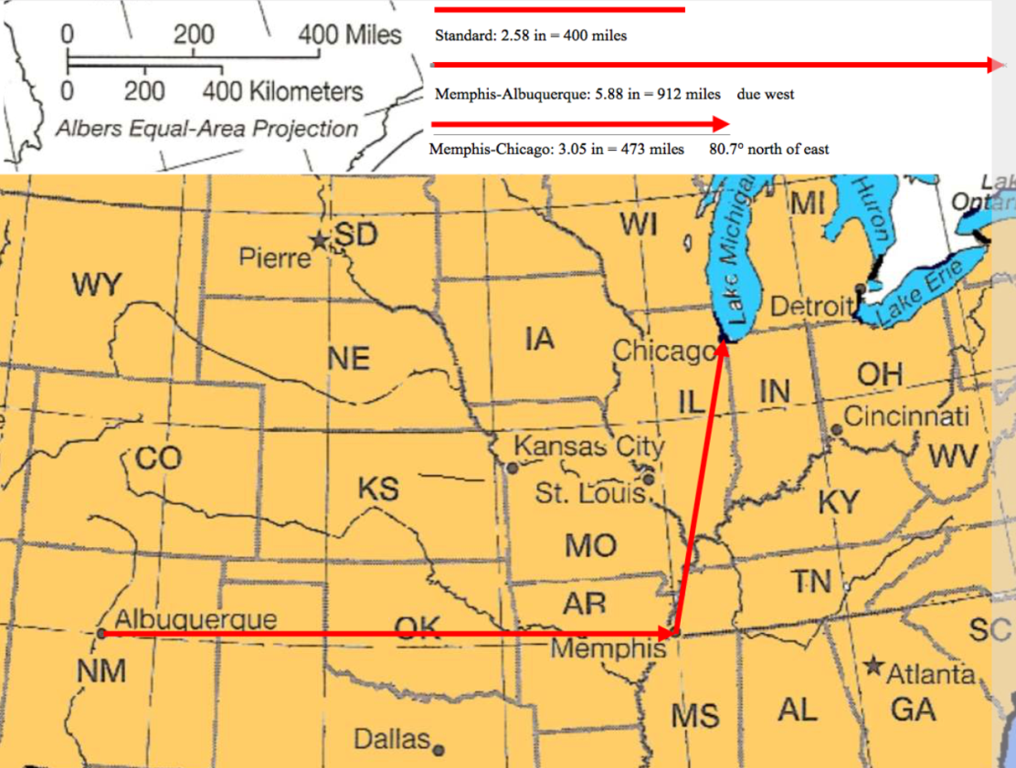

Albuquerque (35°06′39″N, 106°36′36″W) and Memphis (35°07′03″N 89°58′16″W) are almost on the exact same latitude, so we can say that the vector from Albuquerque to Memphis is pointed due east. The comparison to the scale in the diagram shows a distance of 912 miles, so we can write the Albuquerque–Memphis vector as



The comparison to the scale for the Memphis–Chicago vector shows a distance of 473 miles. A protractor shows that the vector makes an angle of 80.7° with the latitude line running through Memphis. Therefore, the Memphis–Chicago vector is



A vector drawn from Albuquerque to Chicago would be the sum of these two vectors:



Use the Pythagorean theorem to find the distance between Albuquerque and Chicago:



The direction of Chicago from Albuquerque is



*Answer:* Answers will vary.

|  |
| --- |
| **SOLUTIONS TO END-OF-CHAPTER PROBLEMS** |

Section 3.1 Coordinate Systems

**P3.1** (a) The distance between the points is given by





(b) To find the polar coordinates of each point, we measure the radial distance to that point and the angle it makes with the +*x* axis:







 measured from the +*x* axis.

**P3.2** (a)  therefore,

*x*1 = (2.50 m) cos30.0°, *y*1 = (2.50 m) sin30.0°, and



*x*2 = (3.80 m) cos120°, *y*2 = (3.80 m) sin 120°, and



(b) 

**P3.3** For polar coordinates (*r*, *θ*), the Cartesian coordinates are (*x* = *r* cos*θ*,   
*y* = *r* sin*θ*), if the angle is measured relative to the +*x* axis.

(a) 

(b) 

(c) 

(d) 

**P3.4** We have 

(a) The radius for this new point is



and its angle is



(b)  This point is in the third quadrant if (*x, y*) is in the first quadrant or in the fourth quadrant if (*x, y*) is in the second quadrant. It is at an angle of .

(c)  This point is in the fourth quadrant if (*x, y*) is in the first quadrant or in the third quadrant if (*x, y*) is in the second quadrant. It is at an angle of .

**Section 3.2 Vector and Scalar Quantities**

**P3.5** In solving this problem we must contrast displacement with distance traveled. We draw a diagram of the skater’s path in ANS. FIG. P3.9, which is the view from a hovering helicopter so that we can see the circular path as circular in shape. To start with a concrete example, we have chosen to draw motion *ABC* around one half of a circle of radius 5 m.

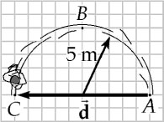

ANS. FIG. P3.5

The displacement, shown as  in the diagram, is the straight-line change in position from starting point *A* to finish *C*. In the specific case we have chosen to draw, it lies along a diameter of the circle. Its magnitude is 

The distance skated is greater than the straight-line displacement. The distance follows the curved path of the semicircle (*ABC*). Its length is half of the circumference: 

A straight line is the shortest distance between two points. For any nonzero displacement, less or more than across a semicircle, the distance along the path will be greater than the displacement magnitude. Therefore:



**Section 3.3 Basic Vector Arithmetic**

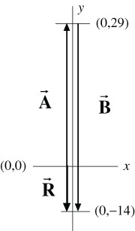**P3.6** We are given . When two vectors are added graphically, the second vector is positioned with its tail at the tip of the first vector. The resultant then runs from the tail of the first vector to the tip of the second vector. In this case, vector  will be positioned with its tail at the origin and its tip at the point (0, 29). The resultant is then drawn, starting at the origin (tail of first vector) and going 14 units in the negative *y* direction to the point (0, −14). The second vector, , must then start from the tip of  at point (0, 29) and end on the tip of  at point

ANS. FIG. P3.6

(0, −14) as shown in the sketch at the right. From this, it is seen that

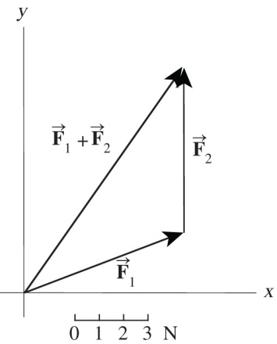 

**P3.7** We find the resultant  graphically by placing the tail of  at the head of . The resultant force vector  is of magnitude  and at an angle of 

ANS. FIG. P3.7

**P3.8** (a) The three diagrams are shown in ANS. FIG. P3.8 below.

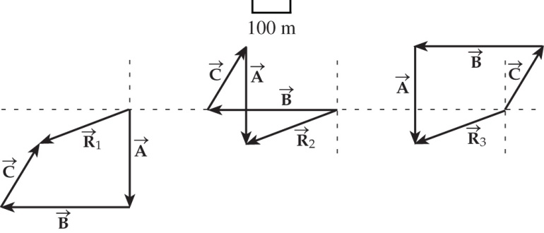

ANS. FIG. P3.8

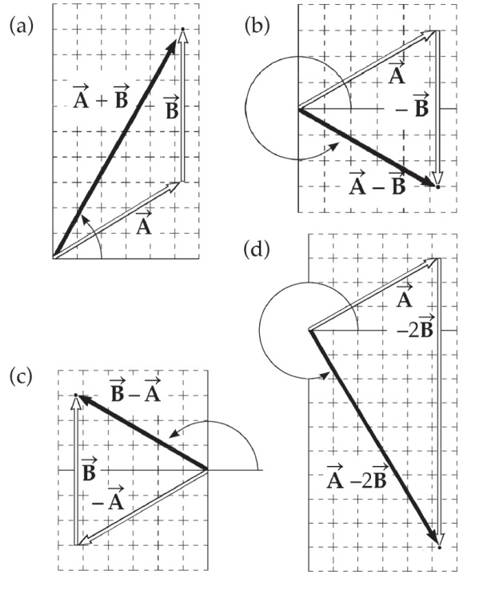 (b) The diagrams in ANS. FIG. P3.8 represent the graphical solutions for the three vector sums:  and 

**P3.9** To find these vector expressions graphically, we draw each set of vectors. Measurements of the results are taken using a ruler and protractor. (Scale: 1 unit = 0.5 m)

(a) 

(b) 

**ans. Fig. P3.9**

(c) 

(d) 

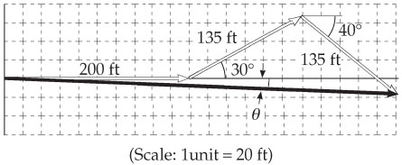**P3.10** The scale drawing for the graphical solution

should be similar to the figure to the right.

The magnitude and direction of the final   
displacement from the starting point are

**ans. Fig. P3.10**

obtained by measuring *d* and *θ* on the

drawing and applying the scale factor

used in making the drawing. The results should be 

**Section 3.4 Components of a Vector and Unit Vectors**

**P3.11** (a) 

(b) Let *v* represent the speed of the camper. The northward component of its velocity is *v* cos 8.50°. To avoid crowding the minivan we require *v* cos 8.50° ≥ 28 m/s.



**P3.12** The person would have to walk



and 

**P3.13** We use the unit-vector addition method. It is just as easy to add three displacements as to add two. We take the direction east to be along  The three displacements can be written as:



The resultant is



(or 9.20 m west and 2.30 m north).

The magnitude of the resultant displacement is



The direction of the resultant vector is given by



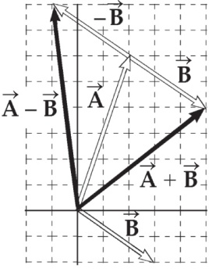**P3.14** (a) See figure to the right.

(b) 

**ans. Fig. P3.14**

(c) 

**P3.15** (a) The single force is obtained by summing the two forces:



We can also express this force in terms of its magnitude and direction:



(b) A force equal and opposite the resultant force from part (a) is required for the total force to equal zero:



**P3.16** We take the *x* axis along the slope downhill. (Students, get used to this choice!) The *y* axis is perpendicular to the slope, at 35.0° to the vertical. Then the displacement of the snow makes an angle of 90.0° + 35.0° + 16.0° = 141° with the *x* axis.

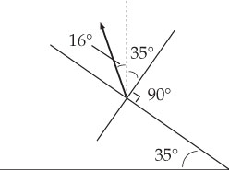

ANS. FIG. P3.16

(a) 

(b) 

**P3.17** (a) We add the components of the three vectors:



(b) Again, using the components of the three vectors,



**P3.18** We are given  and  Solving for  gives



**P3.19** Hold your fingertip at the center of the front edge of your study desk, defined as point *O*. Move your finger 8 cm to the right, then 12 cm vertically up, and then 4 cm horizontally away from you. Its location relative to the starting point represents position vector  Move three-fourths of the way straight back toward *O*. Now your fingertip is at the location of  Now move your finger 50 cm straight through *O*, through your left thigh, and down toward the floor. Its position vector now is 

We use unit-vector notation throughout. There is no adding to do here, but just multiplication of a vector by two different scalars.

(a) 

(b) 

(c) 

**P3.20** We carry out the prescribed mathematical operations using unit vectors.

(a) 

(b) 

**P3.21** The component description of  is just restated to constitute the answer to part (a): *Ax*= −3.00, *Ay* = 2.00.

(a) 

(b) 



*θ* is in the second quadrant, so 

(c) 

*Bx* = *Rx –Ax* = 0 – (–3.00) = 3.00, *By* = *Ry –Ay*= –4.00 – 2.00 = –6.00.

Therefore, 

**P3.22**

|  |  |
| --- | --- |
| The given diagram shows the vectors individually, but not their addition. The second diagram represents a map view of the motion of the ball. According to the definition of a displacement, we ignore any departure from straightness of the actual path of the ball. We model each of the three motions as straight. The simplified problem is solved by straightforward application of the component  method of vector addition. It works for  adding two, three, or any number of vectors. | **ANS. FIG. P3.22** |

(a) We find the two components of each of   
the three vectors



and 



and 



and 

Now adding,



and 

so 

(b) 

**P3.23** (a) Taking components along  and  we get two equations:

6.00*a* – 8.00*b* +26.0 = 0

and

–8.00*a +* 3.00*b* + 19.0 = 0

Substituting *a* = 1.33*b –* 4.33 into the second equation, we find



and so *a* = 1.33(7.00) – 4.33 = 5.00.

Thus  Therefore, 

(b) 

**P3.24** We are given  The magnitude of the vector is therefore



And the angle of the vector with the three coordinate axes is



**P3.25** We use the numbers given in Problem 3.11:



*Ax* = *A* cos *θA* = 3.00cos30.0° = 2.60 m,

*Ay* = *A* sin *θA* = 3.00sin30.0° = 1.50 m

So 





then 

**P3.26**(a) Her net *x* (east-west) displacement is –3.00 + 0 + 6.00 = +3.00 blocks, while her net *y* (north-south) displacement is 0 + 4.00 + 0 = +4.00 blocks. The magnitude of the resultant displacement is



and the angle the resultant makes with the *x* axis (eastward direction) is



The resultant displacement is then 

(b) The total distance traveled is 3.00 + 4.00 + 6.00 = 

**P3.27** We will use the component method for a precise answer. We already know the total displacement, so the algebra of solving a vector equation will guide us to do a subtraction.

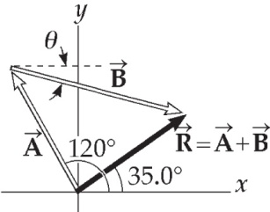 We have 

*Ax* = 150 cos 120° = *−*75.0 cm

*Ay* = 150 sin 120° = 130 cm

**ans. Fig. P3.27**

*Rx* = 140 cos 35.0° = 115 cm

*Ry* = 140 sin 35.0° = 80.3 cm

Therefore,



**P3.28** First, we sum the components of the two vectors for the male:



followed by the components of the two vectors for the female:



**P3.29** The hurricane’s first displacement is



and its second displacement is



With  representing east and  representing north, its total displacement is:



with magnitude 

**P3.30** Let the positive *x* direction be eastward, the positive *y* direction be vertically upward, and the positive *z* direction be southward. The total displacement is then



(a) The magnitude is 

(b) Its angle with the *y* axis follows from 

**P3.31** The *y* coordinate of the airplane is constant and equal to 7.60 × 103 m whereas the *x* coordinate is given by *x* = *vit,* where *vi* is the constant speed in the horizontal direction.

At *t* = 30.0 s we have *x* = 8.04 × 103, so *vi* = 8 040 m/30 s = 268 m/s. The position vector as a function of time is



At  The magnitude is



and the direction is



**P3.32** Note that each shopper must make a choice whether to turn 90° to the left or right, each time he or she makes a turn. One set of such choices, following the rules in the problem, results in the shopper heading in the positive *y* direction and then again in the positive *x* direction.

Find the magnitude of the sum of the displacements:



**P3.33** The displacement from the start to the finish is



The displacement from the starting point to *A* is  meters.

1. The position vector of point *A* is



(b) For *f* = 0 we have the position vector 

(c) 

(d) For *f* = 1 = 100%, we have position vector 

(e) 

**\*P3.34 Conceptualize** A drawing is always a good way to help understand a vector problem. Below is a sketch of the situation.

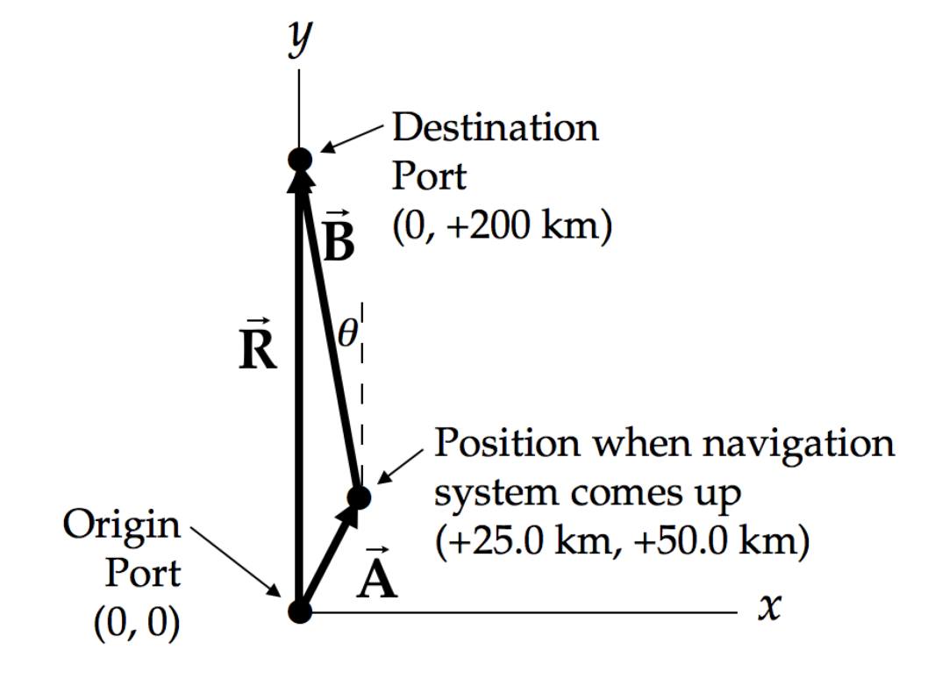

The desired displacement from the position when the system comes up is vector  in the diagram. The desired heading angle is shown as the angle **.

**Categorize** This is a relatively simple problem in vector addition in two dimensions.

**Analyze** As noted in the diagram, we denote the early part of the displacement as vector , the desired vector from the point at which the navigation system comes up as , and the resultant, which is the originally desired displacement, . Vector addition of  and  gives us

 (1)

Separate the *x* and *y* components:

 (2)

Substitute numerical values:



Therefore, expressing the heading with respect to due north,



**Finalize** You should advise the captain to set a heading of 9.46° west of north and maintain that heading to arrive at the destination port. This is the vector  in the figure in the Conceptualize step.

*Answer:* 9.46° west of north

Additional Problems

**P3.35** On our version of the diagram we have drawn in the resultant from the tail of the first arrow to the head of the last arrow. The resultant displacement  is equal to the sum of the four individual displacements,  We translate from the pictorial representation to a mathematical representation by writing the individual displacements in unit-vector notation:

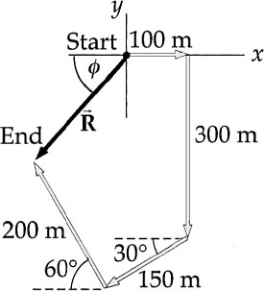

**ANS. FIG. P3.35**









Summing the components together, we find





so altogether



Its magnitude is



We calculate the angle 

The resultant points into the third quadrant instead of the first quadrant. The angle counter-clockwise from the +*x* axis is



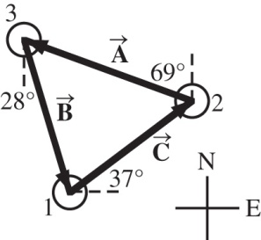**P3.36** Let *A* represent the distance from island 2 to island 3. The displacement is  Represent the displacement from 3 to 1 as  We have 4.76 km at 

**ans. FIG. P3.36**

For the *x* components:





For the *y* components:



(a) We solve by eliminating *B* by substitution:





(b) 

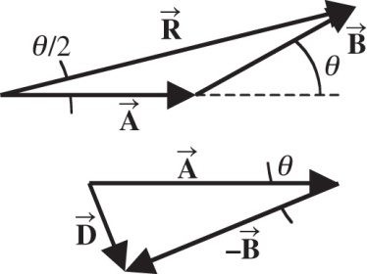**P3.37** Let *θ* represent the angle between the directions of  and . Since  and  have the same magnitudes, , , and  form an isosceles triangle in which the angles are  The magnitude of  is then  This can be seen from

**ans. Fig. P3.37**

applying the law of cosines to the isosceles triangle and using the fact that *B* = *A*.

Again, , , and  form an isosceles triangle with apex angle *θ*. Applying the law of cosines and the identity



gives the magnitude of  as 

The problem requires that *R* = 100*D*.

Thus,  This gives



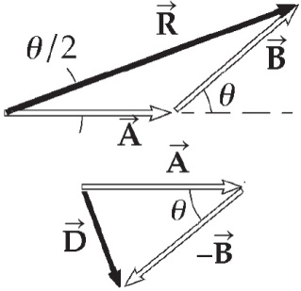**P3.38** Let *θ* represent the angle between the directions of  and. Since  and  have the same magnitudes, , , and  form an isosceles triangle in which the angles are  The magnitude of  is then  This can be seen by applying the law of cosines to the isosceles triangle and using the fact that *B* = *A*. Again, , , and  form an isosceles triangle with apex angle *θ*. Applying the law of cosines and the identity

**ans. Fig. P3.38**



gives the magnitude of  as 

The problem requires that *R* = *nD* or



The larger *R* is to be compared to *D*, the smaller the angle between  and  becomes.

**P3.39** (a) Take the *x* axis along the tail section of the snake. The displacement from tail to head is



Its magnitude is 

From  the time for each child’s run is



Inge wins by 

(b) Olaf must run the race in the same time:



**P3.40** (a) The very small differences between the angles suggests we may consider this region of Earth to be small enough so that we may consider it to be flat (a plane); therefore, we may consider the lines of latitude and longitude to be parallel and perpendicular, so that we can use them as an *xy* coordinate system. Values of latitude, *θ*, increase as we travel north, so differences between latitudes can give the *y* coordinate. Values of longitude, *φ*, increase as we travel west, so differences between longitudes can give the *x* coordinate. Therefore, our coordinate system will have +*y* to the north and +*x* to the west.

Since we are near the equator, each line of latitude and longitude may be considered to form a circle with a radius equal to the radius of Earth, *R* = 6.36 × 106 m. Recall the length *s* of an arc of a circle of radius *R* that subtends an angle (in radians) Δ*θ* (or Δ*φ*) is given by  We can use this equation to find the components of the displacement from the starting point to the tree—these are parallel to the *x* and *y* coordinates axes. Therefore, we can regard the origin to be the starting point and the displacements as the *x* and *y* coordinates of the tree.

The angular difference Δ*φ* for longitude values is (west being positive)



corresponding to the *x* coordinate (displacement west)



The angular difference Δ*θ* for latitude values is (north being positive)



corresponding to the *y* coordinate (displacement north)



The distance to the tree is



The direction to the tree is



(b) 

**P3.41** (a) 

(b) 

(c) 

**\*P3.42**

**Solution**

**Conceptualize** The aircraft are flying in three-dimensional space, so the distance between them is difficult to visualize easily or draw on paper based on the numbers provided. Your goal is to determine a straight-line distance between them to make sure they are far enough apart to be safe.

**Categorize** Despite the difficulty in visualizing the positions of the airplanes, this is a relatively simple substitution problem.

Write a vector expression for each airplane using the suggested axis orientations:



Find the difference vector between these two positions:



Use the Pythagorean theorem to find the distance between the planes:



The two airplanes are just slightly farther apart than the minimum separation distance.]

Answer: 2.28 km

**P3.43** (a) 

(b) The position vector at *t* = 0 is  At *t* = 1 s, the position is  and so on. The object is moving straight downward at 2 m/s, so 

**P3.44** Since

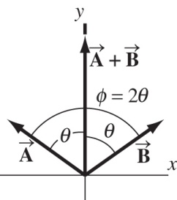 

we have



**ans. Fig. P3.44**

giving 

Because the vectors have the same magnitude and *x* components of equal magnitude but of opposite sign, the vectors are reflections of each other in the *y* axis, as shown in the diagram. Therefore, the two vectors have the same *y* components:

*Ay* = *By* = (1/2)(6.00) = 3.00

Defining *θ* as the angle between either  or  and the *y* axis, it is seen that



The angle between  and  is then 

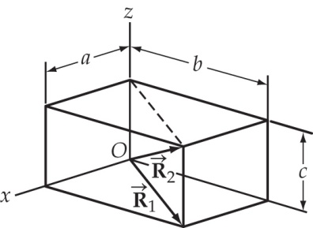**P3.45** (a) From the picture, 

(b) 

**ans. Fig. P3.45**

(c) 

Challenge Problems

**P3.46** (a) You start at point 

The displacement to *B* is



You cover half of this,  to move to



Now the displacement from your current position to *C* is



You cover one-third, moving to



The displacement from where you are to *D* is



You traverse one-quarter of it, moving to



The displacement from your new location to *E* is



of which you cover one-fifth the distance,    
moving to



The treasure is at 

(b) Following the directions brings you to the average position of the trees. The steps we took numerically in part (a) bring you to



then to



then to



and last to





|  |
| --- |
| **ANSWERS TO QUICK-QUIZZES** |

**1.** vectors: (b), (c); scalars: (a), (d), (e)

**2.** (c)

**3.** (b) and (c)

**4.** (b)

**5.** (c)

|  |
| --- |
| **ANSWERS TO EVEN-NUMBERED PROBLEMS** |

**P3.2** (a) (2.17, 1.25) m, (−1.90, 3.29) m; (b) 4.55m

**P3.4** (a) *r*, 180° – *θ*; (b) 180° + *θ* ; (c) –*θ*

**P3.6**  is 43 units in the negative y direction

**P3.8** (a) See ANS. FIG. P3.8; (b) The sum of a set of vectors is not affected by the order in which the vectors are added.

**P3.10** approximately 420 ft at 23°

**P3.12** 1.31 km north and 2.81 km east

**P3.14** (a) See ANS. FIG. P3.14; (b) (c) 6.40 at 38.7°, 8.06 at 97.2°

**P3.16** (a) Its component parallel to the surface is (1.50 m) cos 141° = −1.17 m, or 1.17 m toward the top of the hill; (b) Its component perpendicular to the surface is (1.50 m) sin 141° = 0.944 m, or 0.944 m away from the snow.

**P3.18** 

**P3.20** (a) (b) 

**P3.22** (a) (b) 56.4, 28.7°

**P3.24** 59.2° with the x axis, 39.8° with the y axis, 67.4° with the z axis

**P3.26** (a) 5.00 blocks at 53.1° N of E; (b) 13.00 blocks

**P3.28** magnitude: 170.1 cm, direction: 57.2° above +x axis (first quadrant); magnitude: 145.7 cm, direction: 58.6° above +x axis (first quadrant)

**P3.30** (a) 10.4 cm (b) u 5 35.5°

**P3.32** Impossible because 12.4 m is greater than 5.00 m

**P3.34** 9.46° west of north

**P3.36** (a) 7.17 km; (b) 6.15 km

**P3.38** 

**P3.40** (a) 496 m, 65.1° N of W; (b) The arguments are justified because the distances involved are small relative to the radius of the Earth.

**P3.42** 2.29 km

**P3.44** 

**P3.46** (a) (10.0 m, 16.0 m) (b) This center of mass of the tree distribution is the same location whatever order we take the trees in.